Home page view
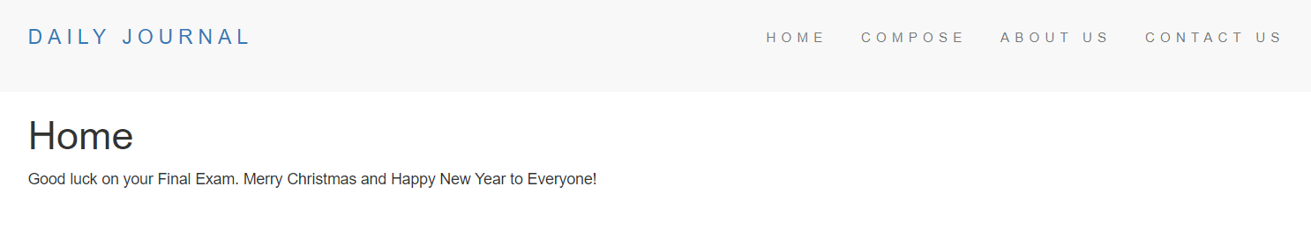
View when the user clicks the “Compose” link on the header
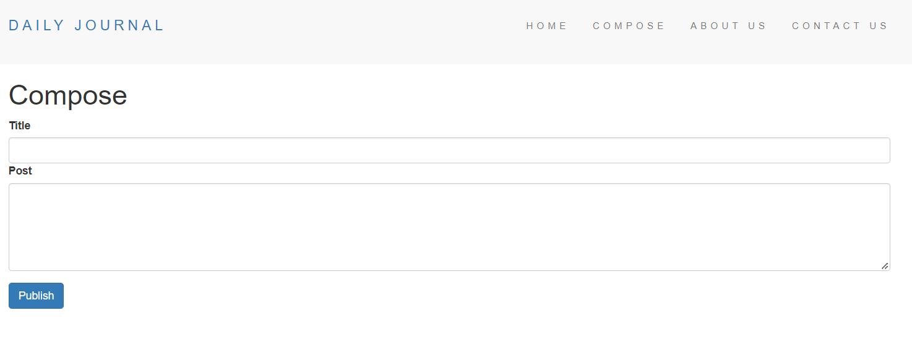
The title, content, and timestamp must be saved in the collection once the user clicks the “Publish” button.
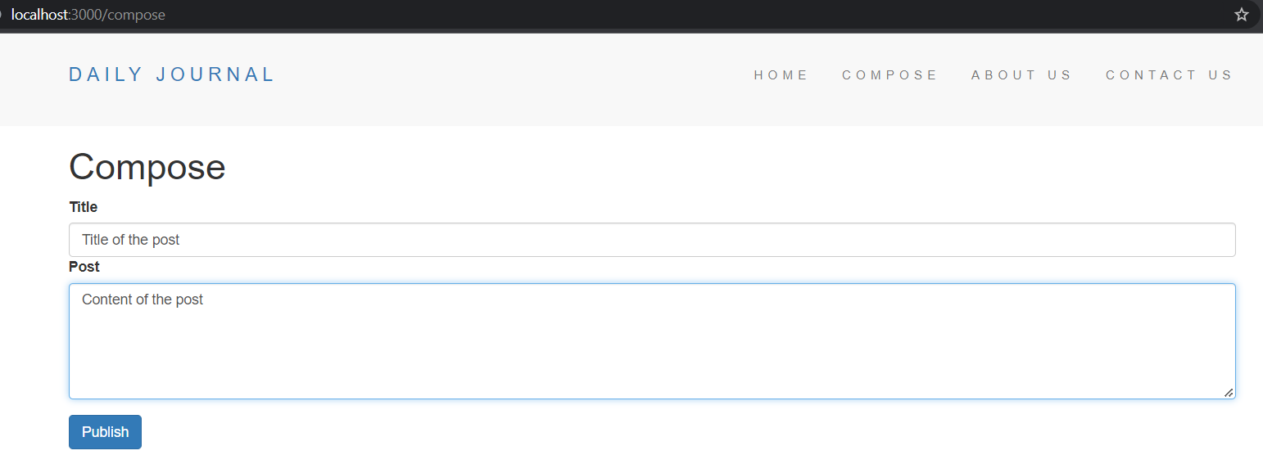
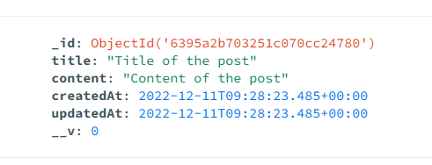
The homepage must display all the contents of the collection.
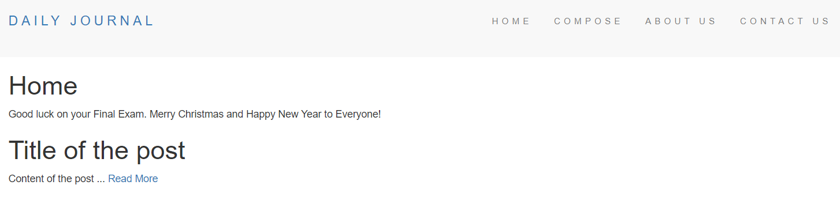
If the user clicks the “Read More” link of the post, the page post.ejs will be rendered with the title, content and timestamp of the post from the collection.
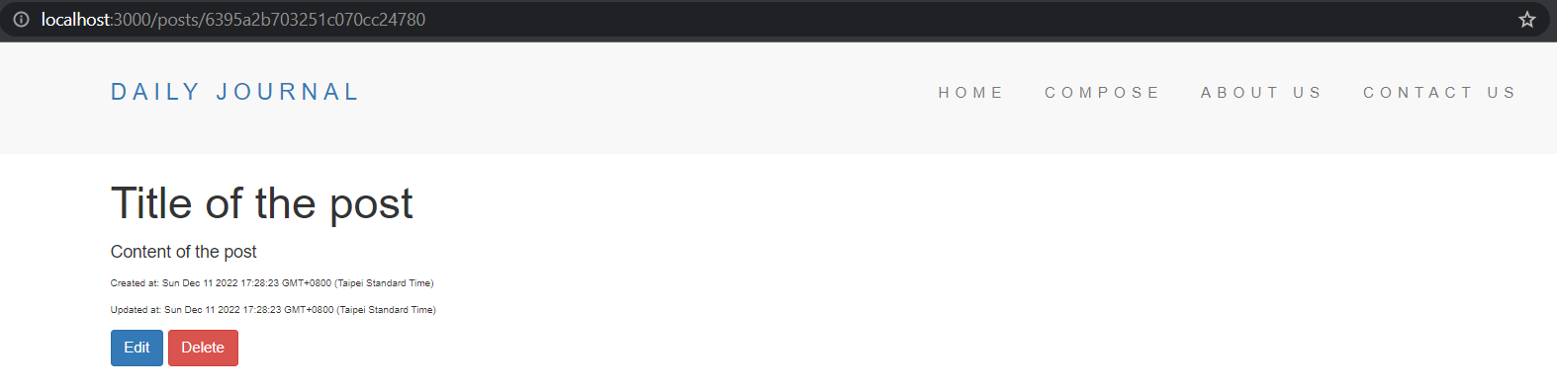
When the user clicks the “Edit” button, this will render the edit.ejs. The edited title/content must be saved in the corresponding entry in the post collection once the user clicks the “Publish” button.
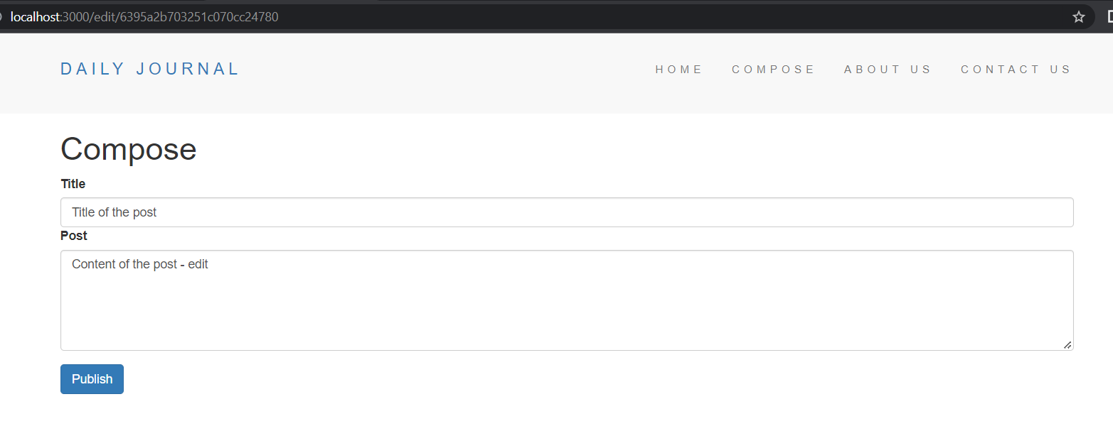
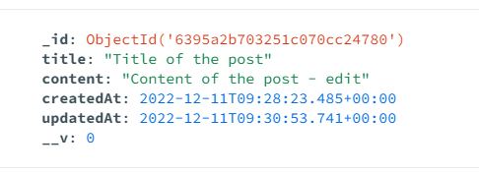

The edited entry should appear on the home page.

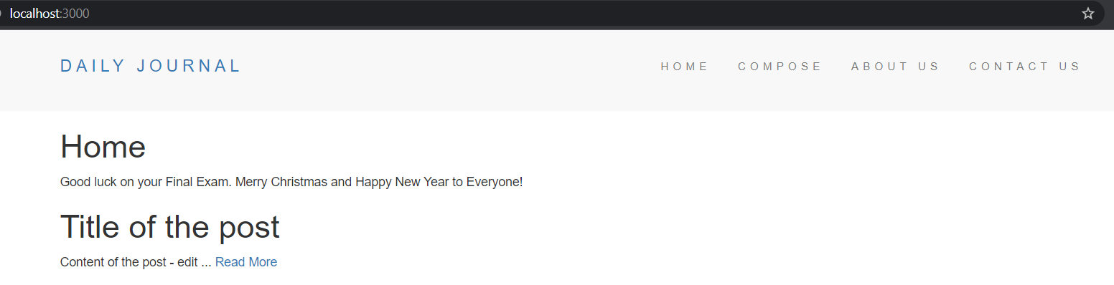

The entry will be deleted in the post collection once the user clicks the “Delete” button and it will be added as a new entry to the collection “archives”.
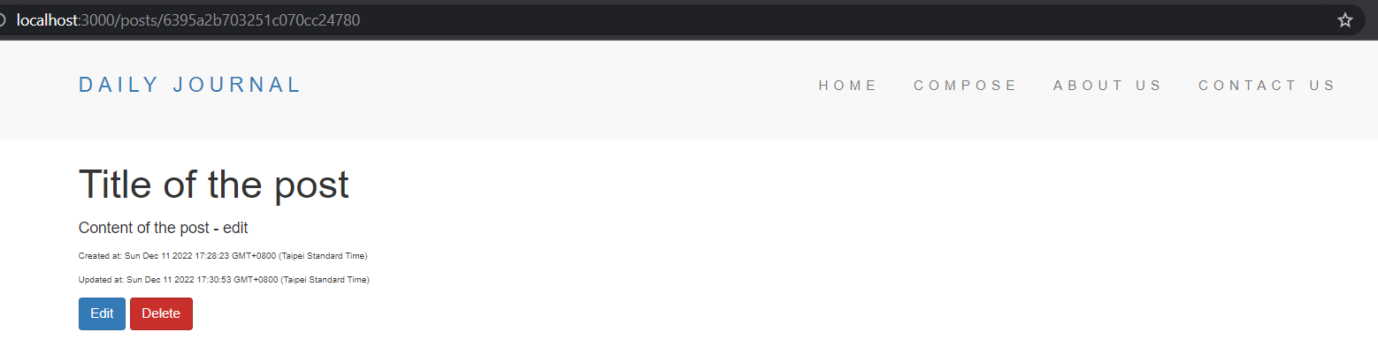

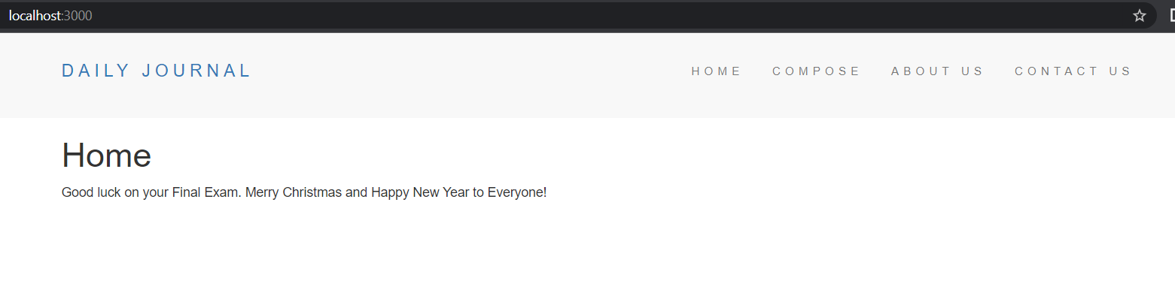

View when the user clicks the “About Us” link on the header. Display the value of the constant “aboutContent”.



View when the user clicks the “Contact Us” link on the header. Display the value of the constant “contactContent”.



